Using Dr. Racket:

1. Download and install Dr. Racket from [**https://racket-lang.org**](https://racket-lang.org) **(version 7.4, as of 10/22/2019)**
2. Once installed, fire up the program DrRacket, under Programs/Racket
3. Under the Language tab at the top, select “The Racket Language”.

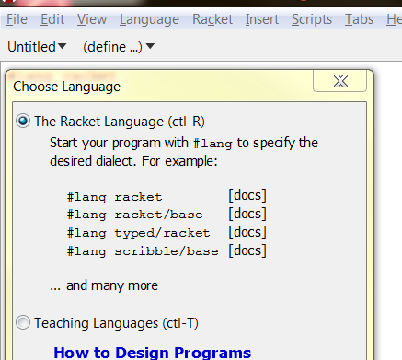

1. Click ok.
2. In the upper rectangle start the r6rs Scheme language

#!r6rs

(import (rnrs))

, and click green run button (upper right corner).

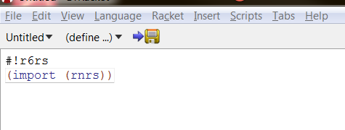

1. Now in the lower rectangle you have a prompt. This is where you can run you Scheme functions. Type in the code, and push the keyboard enter.

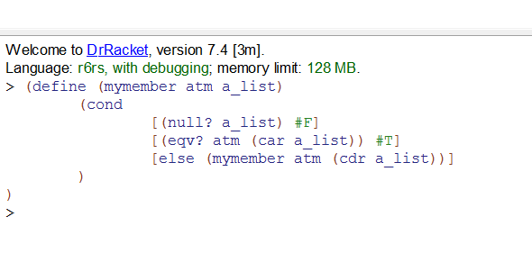

1. Note: some differences from the book (Power Point slides), such as Upper case functions are now lower case, using eqv? instead of eq?, to get a consistent results, and the use of brackets. Also, the name change, as there was already a library Scheme function in Dr. Racket called “member”.
2. Now run the defined function: (mymember 'B '(A B C))



1. Another example:

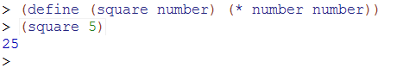

1. One way to clear the bottom rectangle, highlight the

#!r6rs

(import (rnrs))

In the upper rectangle and click on Run green arrow again.